V22.0480.001- iPhone & iPad Programming

Final Project Proposal

Friday, 17 April, 2010

+ Authors:

* Salvatore DiLeo
* Louis Sanchez

+ Project Title: KenKen for the iPhone

+ Overview of the Game:

KenKen is a logic and arithmetic based puzzle game in which you fill a square grid of boxes with numbers. A board consists of n2 boxes, arranged in an n×n grid. Each box is filled with a number, from 1 to n, abiding by a few simple rules:

* The numbers cannot repeat in any row or column.
* The numbers in each heavily outlined set of boxes (cages) must combine (in any order) using the mathematical operation indicated to form the target number shown in the top corner of the cage.
* Cages with only one box are just filled with the target number.
* A number can repeat within a cage as long as it is not in the same row or column.

Board sizes range from 4×4 to 9×9. Sizes outside that range are not really used, though possible. The largest cage sizes seem to be 3 for 4×4 and 5×5 boards, 4 for 6×6 and 7×7 boards, and 5 for 8×8 and 9×9 boards, though there are no official guidelines specifying such. The mathematical operators used are addition, subtraction, multiplication, and division. Also, boxes are not locked once a number is entered, so mistakes can be corrected.

+ An Example 4x4 Board:

Blank Solved

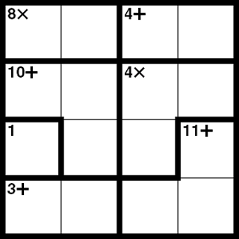 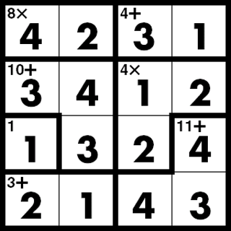

+ An Example 6x6 Board:

Blank Solved

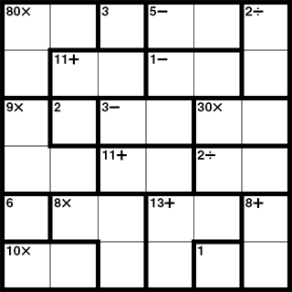 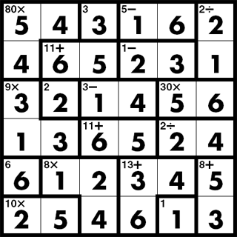

+ Intended Audience: Anyone who enjoys puzzles or logic-based games.

+Main challenges:

* Creating a random board generator that makes sensible boards for the different board sizes.
* Creating a custom view for the “box” element of the puzzle. This view would have properties for every possible feature a box may contain: a number, a target number, a mathematical operator, and any combination of the 4 darkened borders. It would also have to scale properly as the boxes get smaller for larger sized boards.
* Having the cages, target number, and indicated mathematical operation display properly, no matter what board size or what random board is generated.
* Having the user’s current game automatically save upon quitting the app and automatically restoring it the next time the app is started.
* Creating a sliding action for entering the numbers into the boxes.

+ Overall Logic:

The grid of numbers would be created first, with the cages and their associated mathematical operations generated after. Each number belongs to a specific box, which belongs to a specific cage, which in turn belongs to the board.

+ Member Responsibilities: We will both work on all components of the project together.

+ Logic Flow Chart:

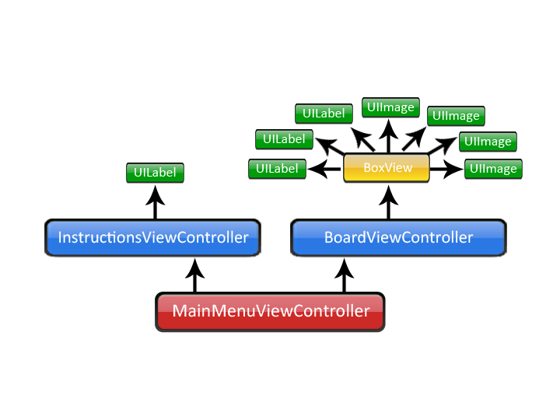

+ Mock-ups of the Major Screens:

Main Menu Instructions

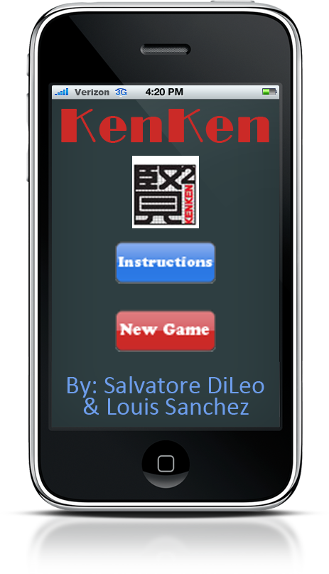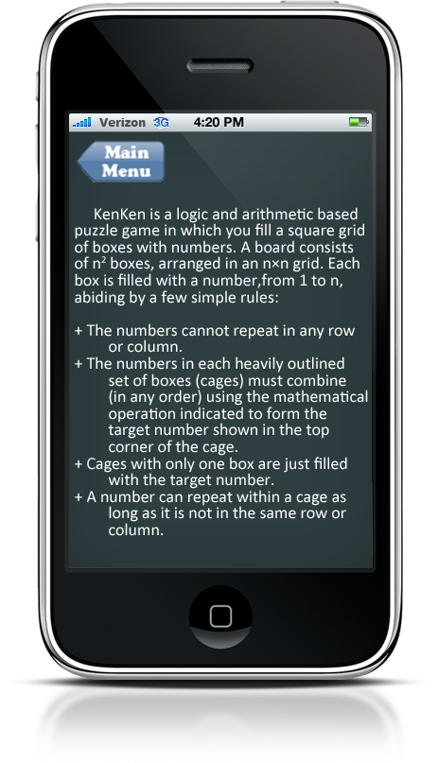

New Board Solved Board

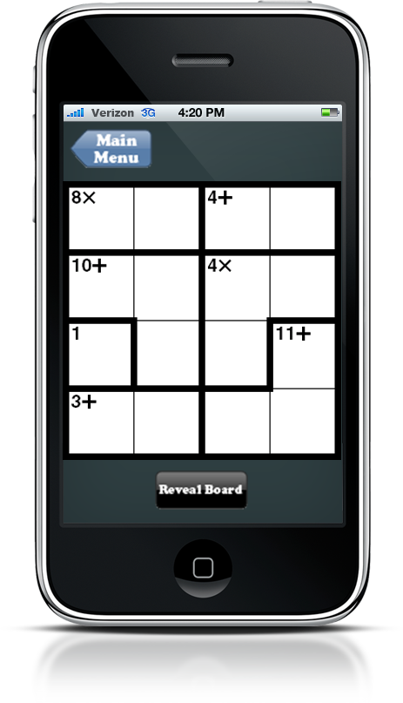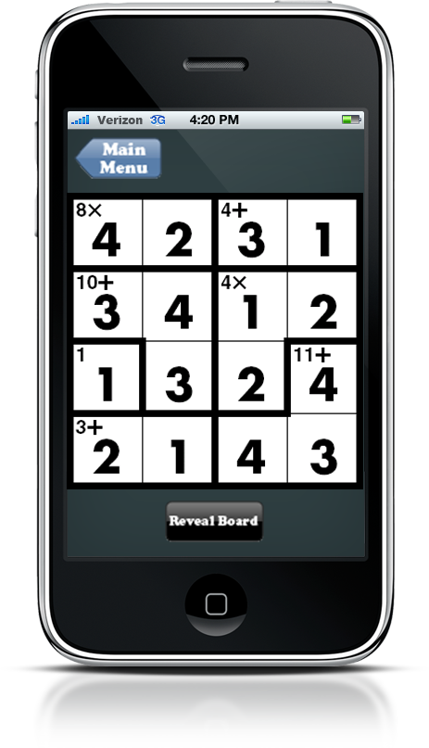

+ Utilizing the iPhone’s Special Features:

* Tapping a box once will open it. Then, choosing the number would be done by sliding one’s finger across the screen in any direction. The number displayed in the box will start at 1. As the user slides his finger further from the point of origin of the box, the number will increase. The scale determining when the number increments would depend on the board size. Once the user lifts his finger, the number displayed would be entered. This sliding action would allow the user to enter the numbers quickly and easily.
* Shaking the iPhone could clear the board, generate a new board, or reveal the solution for the current board.
* Double tapping an individual box would reveal its number.

+ Project Features to be Implemented by Tuesday, 04 May:

* A random board generator, creating sensible boards for 4×4, 5x5, and 6x6 sized boards.
* Automatic saving of the current board when quitting the app, restoring it automatically the next time the app is started.
* The ability to reveal the solution for the current board.
* The ability to clear the current board.
* A touch “sliding” system for entering the numbers into the boxes.
* A clean and simple user interface.
* Including 7x7, 8x8, and 9x9 board sizes.
* Displaying a timer for the user.
* Saving the user’s best times for each board size.
* Allowing multiple boards to be saved at once.
* A notification system that notifies the user if he violates one of the rules:
  + Placing a number in the same row or column a second time.
  + Placing a number in a single-box cage that does not match the target number.
  + Completing a cage by filling its last available box, but its numbers do not form the target number using the indicated mathematical operation.

+ Future Advanced Features:

* Including 7x7, 8x8, and 9x9 board sizes.
* Displaying a timer for the user.
* Saving the user’s best times for each board size.
* Allowing multiple boards to be saved at once.